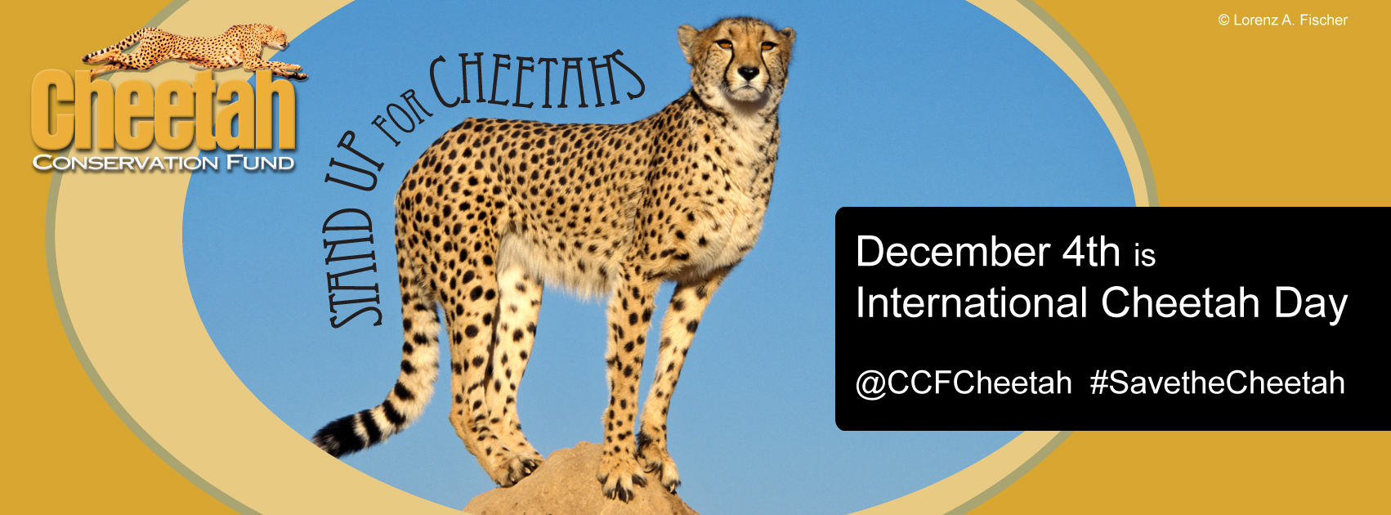

**International Cheetah Day**

**Activities Packet**

In this packet you will find a passport book for children to collect at the start of your Cheetah Day Activities. There are 3 stations worth of activities for children to complete and receive a check in their passport at each station. Educators will find instructions and easy to print activities for a hassle-free event. In this packet you will even find printable prizes and ideas to take your event further. Thank you and your institution for your support, together we can save the wild cheetah.

**Station 1**

**Cheetahs: Built for Speed Instructions**

Materials Needed:

Measuring tape, chalk, masking tape, and stop watch. We recommend that water is available by this station, as participants may get thirsty.

Before children arrive:

Mark out with chalk or tape 30 yards, 8 yards, a long jump area, and tape or chalk line for the balancing portion.

Background – Adaptations

As the fastest animal on land, with a maximum speed of 110 - 120 km per hour, the cheetah can accelerate from 0-80km in 3 seconds. Their top speed can only be maintained for between 400-500 meters resulting in a short burst of speed (20-30s). They then need to rest for about 30 min. Running is a cheetah's main form of defense, its speed allows it to hunt and escape from danger. Over generations the cheetah has evolved many adaptations to facilitate a specialization for speed. Speed consists of the distance one covers in a certain time; therefore by increasing the distance covered one can increase one’s speed.

The cheetah is aerodynamic (stream-lined) for decreased resistance while running. The leg bones are longer in comparison to the other cats and they run on their toes, giving them a longer stride. The cheetah also has a very flexible backbone, which allows it so stretch its body out further. The cheetah's shoulder blades are not connected to the collarbone, thus allowing the shoulders to move freely and help increase the length of the forelegs while running. The hip bones pivot in their sockets, allowing for greater length of the hind legs while running. All these adaptations result in a stride of 8 m at full speed. The lightened skeleton and reduced muscles mass aid the cheetah in running faster by decreasing the weight carried (the larger you are the slower you are). The long tail helps the cheetah to balance and helps the cheetah make sharp turns when running, stabilizes the body and acts as a rudder. A cheetah' foot shows several modifications, allowing for greater grip while running. The pads on the base of the foot bear longitudinal ridges, the function of which is equivalent to tire-treads. The cheetah has semi-retractable claws, which serve a function similar to cleats on a track/soccer shoe. It takes a lot of energy to sustain the top speed of a cheetah, and therefore the cheetah has several adaptations to allow more effective delivery of oxygen to the muscles. In comparison to the other large cats, the cheetah's heart, lungs, nostrils and sinuses are enlarged to increase oxygen supply to the muscles.

**Station 2**

**Cheetah Survival Game Instructions**

Play this game to explore some of the hazards cheetahs encounter in their wild life. A series of numbered station cards are placed in this area. Begin by collecting 2 cheetah cards and then roll the dice to find out which station you will begin your cheetah journey at (roll a 1, 2, 3, or 4).

Then, follow these steps.

1. To start your journey, roll the die and begin on the card with the number you roll, only 1 through 4. If you roll a 5 or 6, just roll again.

2. Follow the instructions on each station card. When conditions are favorable, the card will tell you to move ahead. When you encounter a hazard, you may be delayed or have to go back. If you are told you have lost a cheetah card please give the card back to the instructor. If you gain a cheetah card ask the instructor for your additional cheetah card.

3. REMEMBER! Not all cheetahs live a long life. Some will live, and some will die. Fill out the chart at the end of the journey.

4. Return all cheetah cards at the end of your journey.

**Materials Needed:**

Ribbon for “radio collars”, measured out 8 yard jump, step (a rock, log, step stool, etc.), dice, cheetah cards, printed game stations (1-21)

Cheetah Cards

Print out for Cheetah Survival Game

 

 

 

 

**Station 2: Cheetah Survival Game Chart**

|  |  |
| --- | --- |
| **I Survived**  the Cheetah Survival Game with this # of Cheetah Cards | **I did not Survive** |
|  |  |

**Station 3**

**Cheetah Crafts for Conservation Instructions**

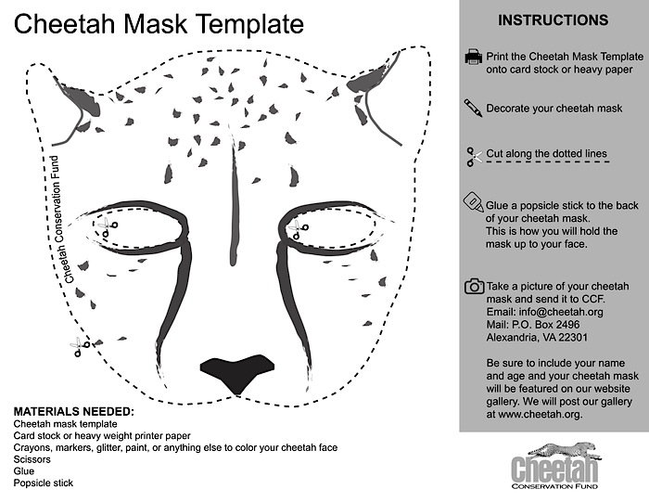

Other Craft Ideas: Quilts for Conservation

Buy a quilt kit from your local craft store or online craft supplier like oriental trading company. You can also go to your local fabric store to purchase low cost muslin that can be cut into 8” squares with lots of ribbon to act as ties or have a volunteer actually quilt it all together. Have children use fabric markers or paint to show what conservation means to them and what they have learned about the cheetah.

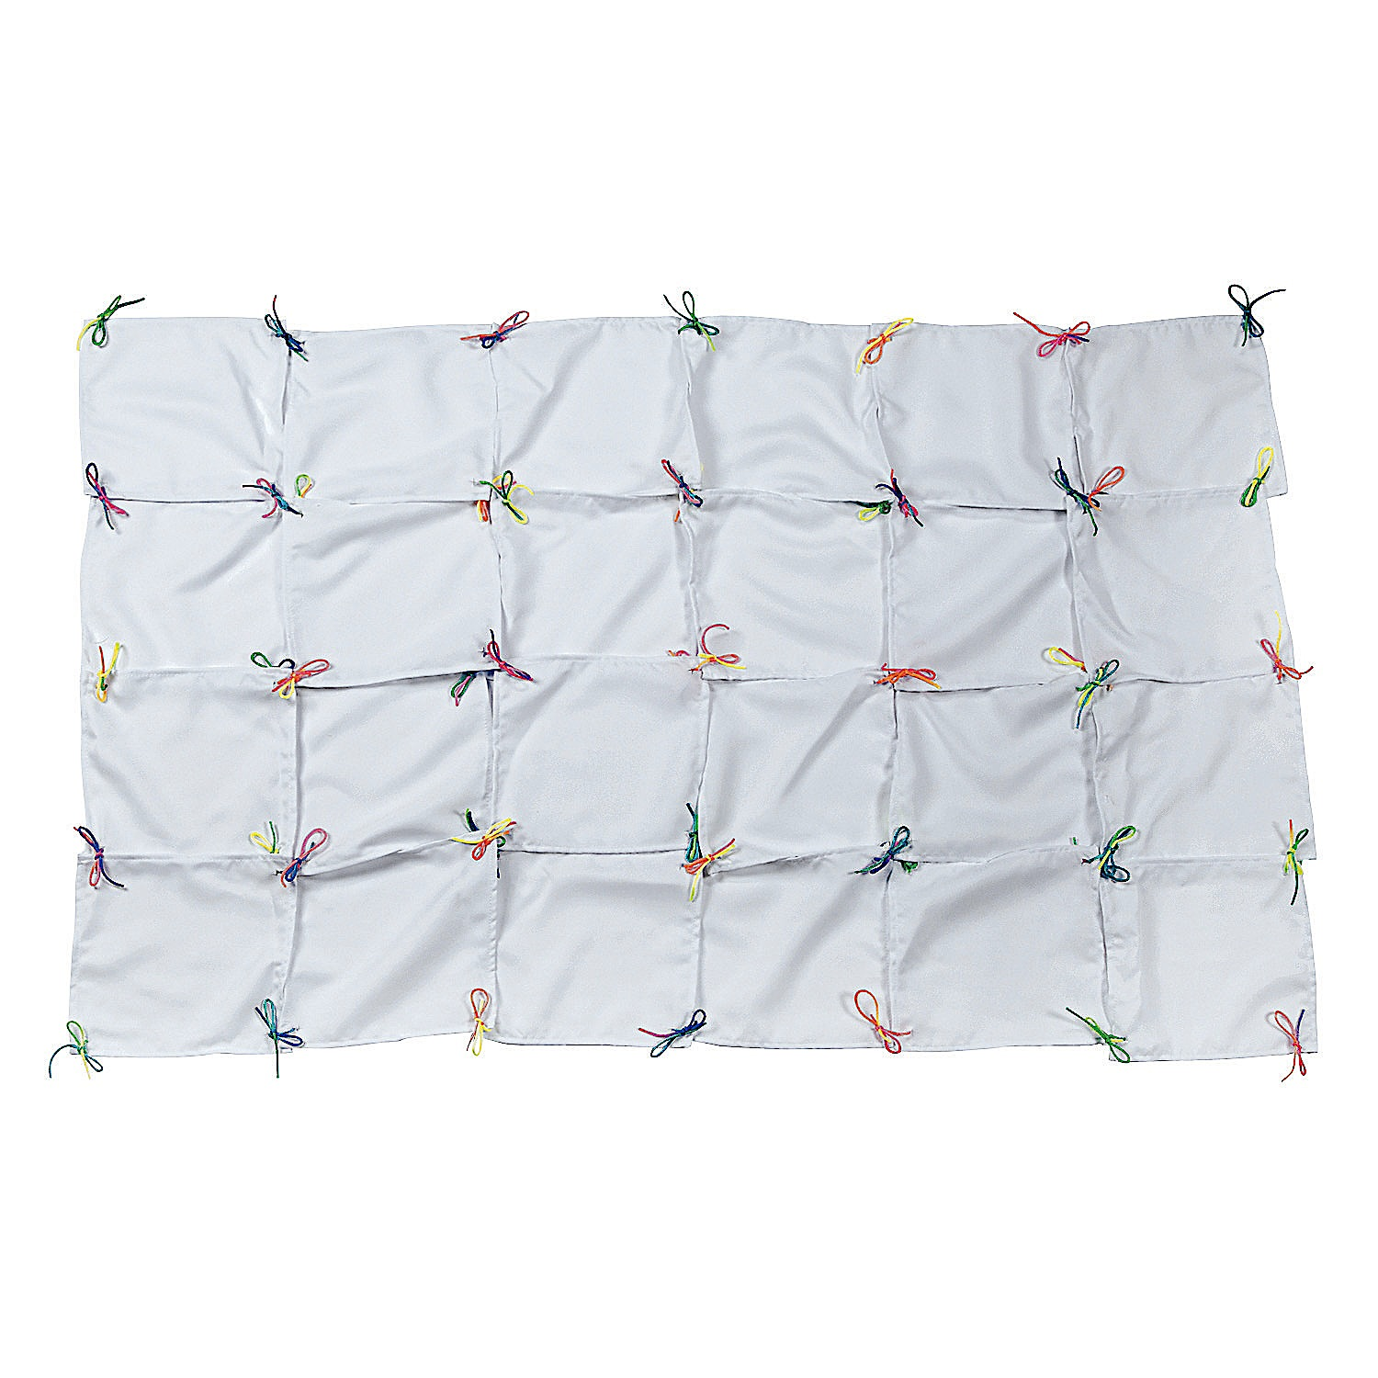

Prizes!

Make stickers prizes!

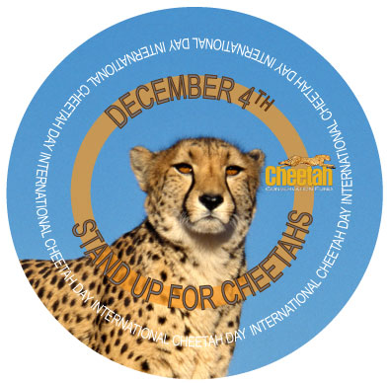Just copy image on sticker paper and print.